# Status Report # 1

Report Date

Jan 22, 2016

Progress Overview

As of this status report we have gotten our project approved, finished and submitted our project statement, figured out or system use cases and have started on or analyses and design document. For the analyses document each team member has been given various tasks to complete for it this week, before the due date on Friday.

Budget Overview

**Cost Overview as of January 22, 2016**

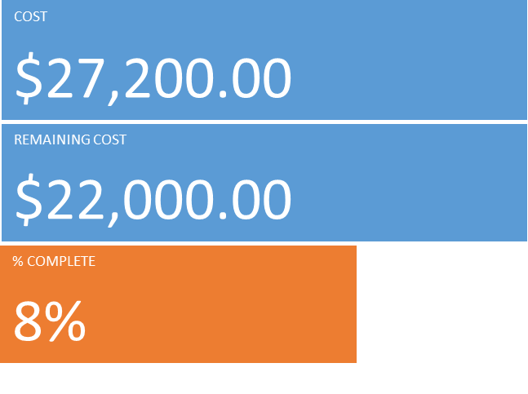

**Cost Status for all top-level tasks**

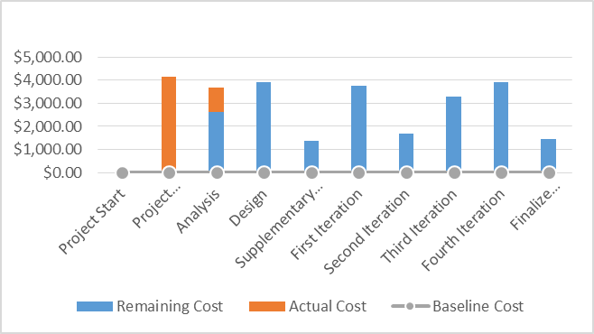

**Cost Status breakdown for all top-level tasks**

|  |  |  |  |  |  |
| --- | --- | --- | --- | --- | --- |
| **Name** | **Actual Cost** | **Remaining Cost** | **Baseline Cost** | **Cost** | **Cost Variance** |
| Project Start | $0.00 | $0.00 | $0.00 | $0.00 | $0.00 |
| Project Management | $4,160.00 | $0.00 | $0.00 | $4,160.00 | $4,160.00 |
| Analysis | $1,040.00 | $2,640.00 | $0.00 | $3,680.00 | $3,680.00 |
| Design | $0.00 | $3,920.00 | $0.00 | $3,920.00 | $3,920.00 |
| Supplementary Requirements | $0.00 | $1,360.00 | $0.00 | $1,360.00 | $1,360.00 |
| First Iteration | $0.00 | $3,760.00 | $0.00 | $3,760.00 | $3,760.00 |
| Second Iteration | $0.00 | $1,680.00 | $0.00 | $1,680.00 | $1,680.00 |
| Third Iteration | $0.00 | $3,280.00 | $0.00 | $3,280.00 | $3,280.00 |
| Fourth Iteration | $0.00 | $3,920.00 | $0.00 | $3,920.00 | $3,920.00 |
| Finalize Application | $0.00 | $1,440.00 | $0.00 | $1,440.00 | $1,440.00 |

Outstanding Issues/Purposed Solutions

There are no current issues.

Change Requests

There are no current change requests.

Plans For Next Period

Our plans for the next period is to get all worked required for the analyses and design document done. Once our individual sections are done we’ll put them together, review the overall document and then submit it on Friday when the document is due. On Friday after the document is submitted we will start looking into the programming side of the project and decide what angle to approach it from.